**Ephesian 3:14-21**

**Session 4: Day 4-5; Pages 96-106**

14 For this reason,

I bow my knee to the Father,

15 from whom every family-clan

in the heavenlies and on the earth

is named,

16 so that he would give to y’all,

according to the richness of his glory,

power to be strengthened

through his Spirit

in your inner human,

17 that the Messiah would dwell

in your hearts

through faith,

having been rooted

and established

in love

18 so that y’all would be empowered

to comprehend

along with all of the holy ones

what is the width and length and height and depth—

19 to know the

far-beyond knowing

love of the Messiah

so that y’all would be filled up

unto all the fullness of God.

20 Now to the one who is powerful

beyond all things

to do overabundantly more

than what we would ask or conceive,

according to the power which is at work in us,

21 to him be glory

in the church

and in Messiah Jesus

for all generations of the age of the ages, amen

Review of Ephesian 1-3

* Chapter 1: What God has done for us.
  + Emphasis: God’s sovereignty
* Chapter 2:1-10: What Christ has done in us.
  + Emphasis: Grace
* Chapter 2:11-3:21: What Christ has done between us.
  + Emphasis: Reconciliation
* Focuses on a vertical relationship with God
* Orthodoxy: True/Right beliefs/teachings. Based on heavenly/scriptural truths (Chapters 1-3)

Overview of Ephesians 3:14-21

* Is a form of an intercessory prayer: Praying to God on behalf of someone else.
* Paul is pleading with God that his readers would understand the magnitude of God’s love, grace, mercy, power; all through Christ, for us.

What is Paul referring to when he says, “For this reason?”

* The reason of God’s grace in bringing Jews and Gentiles together in Christ
* All that God has blessed us with
* 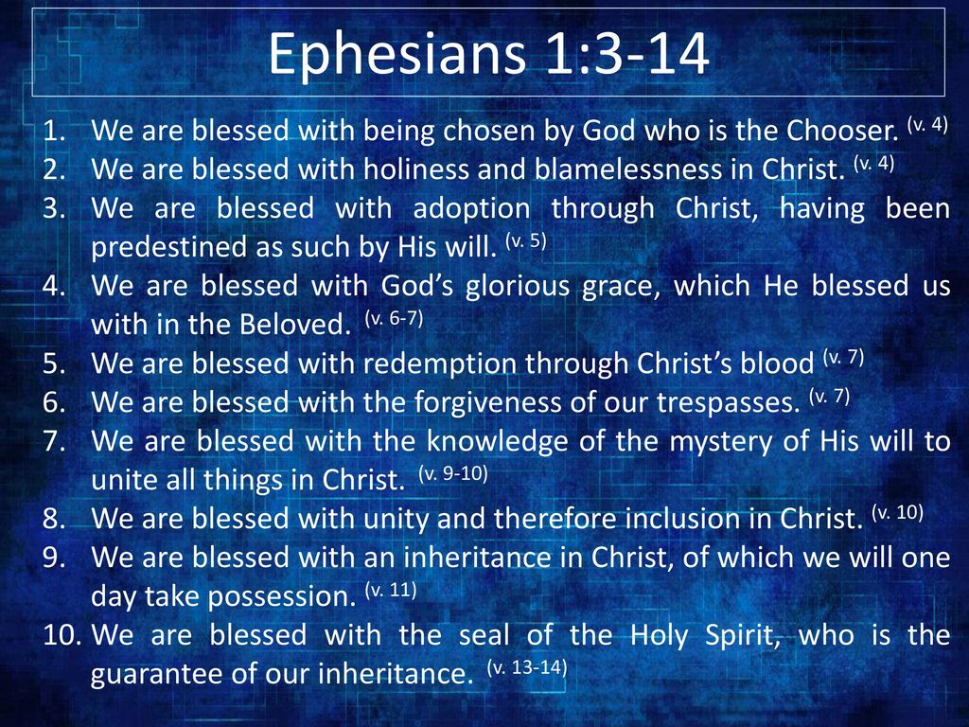
* All that we now have in Christ
  + A new life
  + Salvation by grace through faith
  + Forgiveness of sins
  + Reconciliation with God
  + A spiritual identity as God's handiwork,
  + Created for good works
  + A complete transformation from spiritual death to a living relationship with God through Jesus Christ
  + ALL because of God's grace and not our own merit

“I bow my knee to the Father.” What does bowing down infer?

* Submission
* Pleading
* Worship and reverance
* Supplication (petition. Asking for something on behalf of someone else)
  + One party humbly or earnestly asks another party to provide something, either for the party who is doing the supplicating
* Humbling self

Question 34: What is Paul requesting in this prayer? What is Paul praying for? What does Paul want his readers to be rooted in? What does he want them to comprehend?

What does it mean to be rooted? What do you think of when you hear that statement?

Question 39: In your own words, what does it mean to be rooted in Christ’s love? What is the fruit of being rooted in Christ’s love? How can we have access to Christ’s love?

Question 46: How has Paul woven the three members of the Godhead into this text? Who are they? What are the things he has described them doing?

Question 47: What has Paul taught us about: (in all of Ephesians 1-3)

|  |  |  |
| --- | --- | --- |
| God the Father | God the Son | God the Holy Spirit |
|  |  |  |

In his prayer that Christ would dwell in the hearts of the Ephesian believers (3:17), Paul uses the Greek word *katoikeo,* which refers to settling down or permanently residing somewhere. What does it mean to have Christ residing in you?

In what ways should His presence affect the way you live? (Hint, we will begin to learn this in Chapter 4). What can you do to remember that Christ is dwelling in you?

Paul wants the Ephesian believers to understand just how wide, long, high, and deep Christ’s love is (3:18). Yet if the love of Christ surpasses knowledge (3:19), how can we know it?

The Greek word for “knowledge” (*gnosis*) often refers to knowledge gained through experience. In what ways have you experienced the love of Christ? How do these experiences help you understand Christ’s love?

Paul concludes his prayer with a benediction (simply a blessing; a short prayer for divine help, blessing, and guidance) and a doxology (a statement of praise to God). How does he describe God in these verses?

How is God challenging you to live transformed by the power of His Word?

14 For this reason, What reason? What he has been talking about from Chapter 2. Christ makes us alive in him. We are his workmanship. We are no longer strangers and aliens, but fellow citizens with saints and elders. We are God’s household. We are build upon the foundation of the apostles and prophets. We are being built together into a dwelling of God in the Spirit. OUR NEW IDENTITY MAKES US THE DWELLING PLACE OF GOD. We have a great status provided in Christ and Paul wants us to use.

I bow my knee to the Father, What does bowing infer? (prayer of submission and worship to God, supplication). Humbling self. Bowing is a gesture of respect, submission, <https://www.gotquestions.org/bowing-kneeling-prayer.html>

15 from whom every family-clan Who? God, is the father of all

in the heavenlies and on the earth

is named, both in Heaven and on Earth (ALL people of ALL times)

16 so that he would give to y’all, So that; (linking word/phrase. A Conjunction. A phrase that links words that aim to phrases or actions. SO that is used to express purpose). Do this, so that, you will gain this…

according to the richness of his glory, Paul is starting his central request here for the family of believers. Focusing on that God would grant them “according to” his richness.

Illustration of a wealthy person giving “according to” rather than “out of” his riches. For a millionaire to give $50 or $100 would be simply to give out of his wealth. But to give $25,000 would be to give according to his wealth. The greater a person’s wealth, the greater his gift must be to qualify for giving according to his wealth.

For God to give “according to the riches of his glory” is absolutely staggering, because His richers are limitless, completely without bound. WE HAVE A SPIRITUAL WEALTH IN CHRIST.

power to be strengthened 2nd request from Paul for believers. This is the first step in living like God’s children

through his Spirit The Spirit is our Helper, the 3rd revealed person of the trinity,but not the least. HE is still fully God.

in your inner human, What is our inner man? Our soul. Where the Spirit works in us. Our divine nature, given at salvation is at the center of the inner man and is the base from which the Holy Sprit changes the thinking of the believer

17 that the Messiah would dwell Our inner being must be strengthened for a reason and that reason (purpose) is for Christ to dwell in us, when we believe.The greek word for dwell is Katoikeo. Formed from kata, meaning down, and oikeo meaning to inhabit a house. This dwell doesn’t just mean that he is present in our hearts but is “at home” in our hearts. He settles down as a family member.

in your hearts Jesus enters our hearts at salvation. But he cannot live there comfortable and satisfied until it is cleansed of sin and filled with his will.

through faith, What does absolute faith look like?

having been rooted Remember all the spiritual blessings and being “in Christ”? When we hold these truths in our hearts, we are being made strong inwardly. Rooted in His truths. Settled on a strong foundation of God’s love.

and established Definition of established; “having been in existence for a long time and therefore recognized and generally accepted.

in love

18 so that y’all would be empowered the purpose of being rooted is to be empowered. What does empowerment look like?

to comprehend

along with all of the holy ones

what is the width and length and height and depth— Because we are rooted and established in love, we become able to comprehend the magnitude of the love we are given.. We still cannot fully comprehend the fullness of love because our finite brains cannot fathom an infinite God. But we can touch the surface of the chasm of God’s infinite love

19 to know the

far-beyond knowing

love of the Messiah when we are rooted in love, we know the love that Christ has for us. The cross shows us this love. His selfless, sacrificial, and forgiving

so that y’all would be filled up Purpose again…The spirit would strengthen us, Christ would dwell in us, which leads to being empowered and leads to abundant love, which then leads to knowing the fullness of God.

unto all the fullness of God. What is the fullness of God? God wants us to be filled with him? How amazing is that. This is so hard to wrap my brain around. I will continue to seek his face to know and love everything I can about God.

He wants us to be with him. He wants to make us like him, by filling us with Himself, all that HE is and has!!! WOW.

To even try to understand this we need to look to him. Every attribute and characteristic of God. His power, majesty, wisdom, love, mercy, patience, kindness, longsuffering, and everything else…

To be filled with the fullness of God is to be totally dominated by Him,with nothing left of self. To be filled with God is to be emptied of self. Luke 9:23-24; 1 Corinthians 15:31

What does dying to self look like?

Discipline, overcoming temptations, filling yourself with Christ, battle with the world, flesh, sin, sanctification.

20 Now to the one who is powerful Paul shifts his focus of his prayer back to God. The one who is powerful, beyond everything. This is a praise to God. Began his first section of Ephesians with a praise to God and ending with a praise.

God is able.

God is able to do.

He is able to do exceeding abundantly.

He is able to do exceeding abundantly beyond all that we ask.

He is able to do exceeding abundantly beyond all we ask or think.

He can do more than we think, conceive, know…

beyond all things

to do overabundantly more

than what we would ask or conceive,

according to the power which is at work in us, What is the power at work in us? Look back to what was just expressed in verses 16-19. The spirit would strengthen us, Christ would dwell in us, which leads to being empowered and leads to abundant love, which then leads to knowing the fullness of God.

When the Holy Spirit has empowered us, Christ has indwelt us, love has mastered us, God has filled us with his own fullness, THEN he is able to do exceeding abundantly beyond all that we ask or think. We must be submitted to him.

21 to him be glory All glory belongs to him. He deserves all of the glory both now, past, and future in the Church, through Jesus and through all generations.

in the church

and in Messiah Jesus

for all generations of the age of the ages, amen Amen is derived from the Hebrew āmēn, which means “certainly, truth, and verily”.

In order for God to truly be glorified, we must yield to what Paul has exhorted (strongly encourage or urge someone to do something) over us in this prayer.