**Ephesian 3:14-21**

**Session 4: Day 4-5; Pages 96-106**

Review of Ephesian 1-3

* Chapter 1: What God has done for us.
  + Emphasis: God’s sovereignty
* Chapter 2:1-10: What Christ has done in us.
  + Emphasis: Grace
* Chapter 2:11-3:21: What Christ has done between us.
  + Emphasis: Reconciliation
* Focuses on a vertical relationship with God
* Orthodoxy: True/Right beliefs/teachings. Based on heavenly/scriptural truths (Chapters 1-3)

Overview of Ephesians 3:14-21

* Is a form of a supplication prayer: Praying to God on behalf of someone else. Humbly asking for something on behalf of someone else. Supplication prayer is specifically for believers. Intercession prayer is for unbelievers.
* Paul is pleading with God that his readers would understand the magnitude of God’s love, grace, mercy, power; all through Christ, for us.
* Paul is exhorting believers to understand what all he has been telling them about God, Christ, and the Holy Spirit.

**Ephesians 3:14-21.** **Let’s Break it Down**

14 For this reason,

I bow my knee to the Father,

15 from whom every family-clan

in the heavenlies and on the earth

is named,

16 so that he would give to y’all,

according to the richness of his glory,

power to be strengthened

through his Spirit

in your inner human,

17 that the Messiah would dwell

in your hearts

through faith,

having been rooted

and established

in love

18 so that y’all would be empowered

to comprehend

along with all of the holy ones

what is the width and length and height and depth—

19 to know the

far-beyond knowing

love of the Messiah

so that y’all would be filled up

unto all the fullness of God.

20 Now to the one who is powerful

beyond all things

to do overabundantly more

than what we would ask or conceive,

according to the power which is at work in us,

21 to him be glory

in the church

and in Messiah Jesus

for all generations of the age of the ages, amen

What is Paul referring to when he says, “For this reason?”

“I bow my knee to the Father.” What does bowing down infer?

Question 34: What is Paul requesting in this prayer? What is Paul praying for? What does Paul want his readers to be rooted in? What does he want them to comprehend?

What does it mean to be rooted? What do you think of when you hear that statement?

Question 39: In your own words, what does it mean to be rooted in Christ’s love? What is the fruit of being rooted in Christ’s love? How can we have access to Christ’s love?

Question 46: How has Paul woven the three members of the Godhead into this text? Who are they? What are the things he has described them doing?

Question 47: What has Paul taught us about: (in all of Ephesians 1-3)

|  |  |  |
| --- | --- | --- |
| God the Father | God the Son | God the Holy Spirit |
|  |  |  |

In his prayer that Christ would dwell in the hearts of the Ephesian believers (3:17), Paul uses the Greek word *katoikeo,* which refers to settling down or permanently residing somewhere. What does it mean to have Christ residing in you?

In what ways should His presence affect the way you live? (Hint, we will begin to learn this in Chapter 4). What can you do to remember that Christ is dwelling in you?

Paul wants the Ephesian believers to understand just how wide, long, high, and deep Christ’s love is (3:18). Yet if the love of Christ surpasses knowledge (3:19), how can we know it?

The Greek word for “knowledge” (*gnosis*) often refers to knowledge gained through experience. In what ways have you experienced the love of Christ? How do these experiences help you understand Christ’s love?

Paul concludes his prayer with a benediction (simply a blessing; a short prayer for divine help, blessing, and guidance) and a doxology (a statement of praise to God). How does he describe God in these verses?

How is God challenging you to live transformed by the power of His Word?

Responses for Question: What is Paul referring to when he says, “For this reason?”

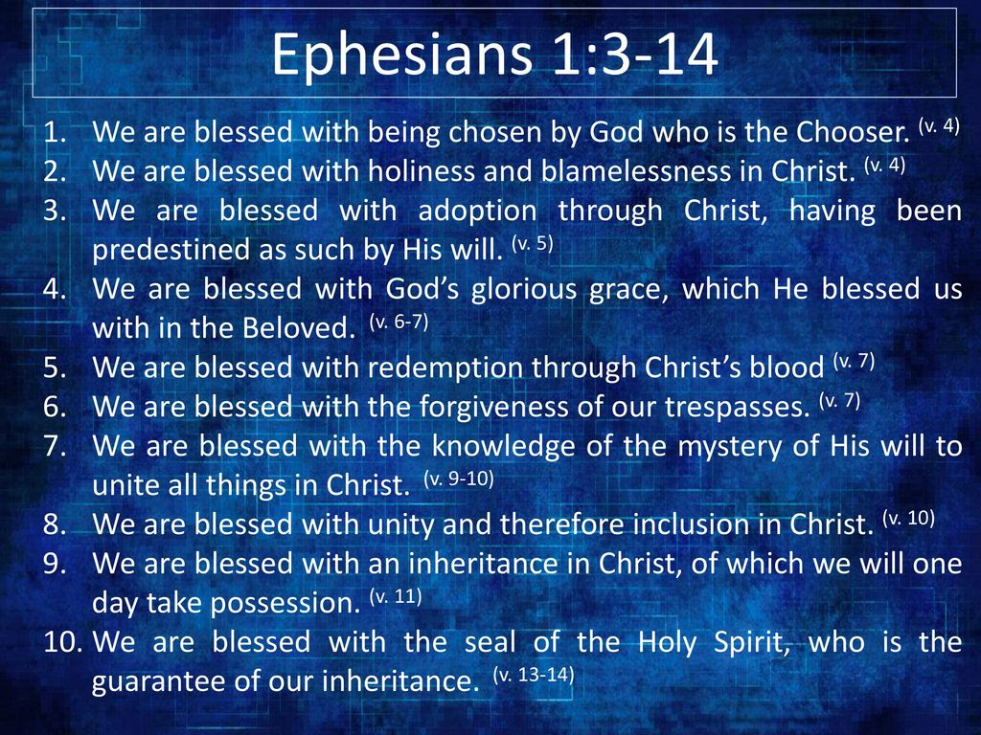

* All that we now have in Christ
  + A new life
  + Salvation by grace through faith
  + Forgiveness of sins
  + Reconciliation with God
  + A spiritual identity as God's handiwork,
  + Created for good works
  + A complete transformation from spiritual death to a living relationship with God through Jesus Christ
  + ALL because of God's grace and not our own merit